Barmoor 1982 Trust
Charity Donation Form
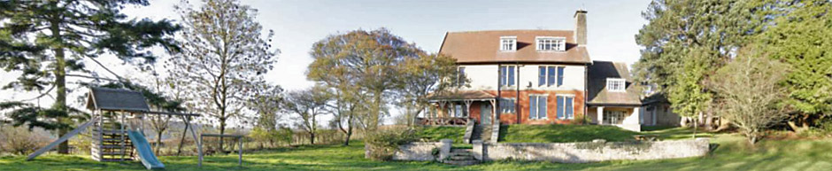

Barmoor is run by a non-profit charity of volunteers.
Donation from well-wishers helps us to fund maintenance and improvements to the house for now and the future. Small or larger amounts are all welcome!
If you would like to donate by cash or cheque, please complete this form.

Leave it with the donation in the ‘breakages box’ in the kitchen, or send to
Lucy White, Barmoor Treasurer, 15 Dunloe Avenue, London, N17 6LB.

A new Online donation route is under review, but should soon reappear on our website at www.barmoor.org.uk

I am donating £………………. to be used for general purposes of the Trust.

If you wish to gift for a specific purpose, please discuss this with our treasurer first.

Gift Aid is reclaimed by the charity from the tax you pay for the current tax year and boosts your donation by 25%. Your address is needed to identify you as a current UK taxpayer.
- I want to Gift Aid my donation and any donations I make in the future or have made in the past 4 years to The Barmoor 1982 Trust
I am a UK taxpayer and understand that if I pay less Income Tax and/or Capital Gains Tax in the current tax year than the amount of Gift Aid claimed on all my donations it is my responsibility to pay any difference.
Please notify us if you:
• want to cancel this declaration
• change your name or home address
• no longer pay sufficient tax on your income and/or capital gains

Have you ticked the box if you wish to Gift Aid?
Full Name
…………………………………………………….
Home address
…………………………………………………….
…………………………………………………….
…………………………………………………….
Signature
…………………………………………………….
Date ………………………………………...

